Veterinary Management System
Created by: 92400133037- Heer Mehta
92400133169- Rishi Sampat

Submitted to: Prof. Drashti
Faculty of DBMS/ICT

INDEX
SR. NO. | Topics | Page No.
1 | Abstract | 3
2 | Objectives | 4
3 | System Modules | 5
4 | ER Diagram | 9
5 | DataBase Schema | 10
6 | Normalization | 13
7 | Queries (LAB PART)/ Procedures/ Triggers | 15
8 | Snapshots | 16
9 | Future Scope | 25
10 | Conclusion | 26

ABSTRACT
The Veterinary Management System is a comprehensive, database-driven application developed to streamline and integrate the various operations of a modern veterinary clinic. It brings together clinical management, e-commerce services, pet care facilities, and inventory tracking into a single unified platform. The main objective of the system is to efficiently handle patient records, appointments, medical prescriptions, and laboratory reports, while also enabling online product purchases and grooming service bookings.

The system is built using a relational database model implemented in MySQL, ensuring data integrity, consistency, and scalability. Key entities such as users, pets, doctors, products, orders, and services are organized into well-structured, normalized tables to reduce redundancy and maintain efficient data management. Relationships between these entities are defined using primary and foreign keys, closely reflecting real-world interactions within the system.

To enhance performance and maintain data accuracy, advanced database concepts such as normalization (up to Third Normal Form), indexing, and constraints are applied. Stored procedures are used to handle commonly performed operations like appointment booking and order management, while triggers automate essential tasks such as updating inventory and checking stock availability. Views are implemented to simplify complex queries and ensure secure access to data.

The system also incorporates role-based access control, allowing different types of users—including administrators, doctors, receptionists, lab technicians, beauticians, and customers to interact with the system according to their specific roles and responsibilities. This approach improves both usability and security.

Overall, this project demonstrates a practical, real-world application of database management concepts by integrating healthcare, retail, and service modules into a single digital ecosystem. It highlights the importance of efficient database design, automation, and data integrity in developing scalable and reliable systems.

OBJECTIVES
The primary objective of the Veterinary Management System is to design and implement a robust and efficient database system that brings together different aspects of veterinary clinic operations into one unified platform. The system focuses on improving data organization, accessibility, and overall operational efficiency, while ensuring data integrity and scalability.
The key objectives of the project are as follows:
- To manage patient and pet records efficiently
- The system maintains detailed information about pets, including their medical history, appointments, and treatments, ensuring quick access and improved healthcare management.
- To streamline appointment scheduling and clinical operations
- It supports the booking, tracking, and management of appointments between pet owners and doctors, helping reduce manual errors and enhance service efficiency.
- To handle medical prescriptions and laboratory reports
- The system stores prescriptions and test results in a well-structured format, making it easier for doctors and staff to access and update medical information when needed.
- To integrate an e-commerce module for pet-related products
- It allows users to browse, purchase, and track orders for medicines, pet food, toys, and grooming products through an online interface.
- To maintain inventory and stock management
- The system monitors product availability, automatically updates stock levels, and records inventory changes to avoid inconsistencies and shortages.
- To provide pet grooming and care service management
- It enables the booking and allocation of grooming services such as bathing, cleaning, and hair cutting, improving convenience for customers.
- To implement role-based access control
- Different users including administrators, doctors, receptionists, lab technicians, beauticians, and customers are given controlled access based on their roles and responsibilities.
- To ensure data integrity and minimize redundancy through normalization
- The database is designed using normalization techniques (up to Third Normal Form) to maintain consistency and eliminate duplication.
- To automate operations using advanced DBMS features
- Stored procedures, triggers, and constraints are utilized to automate tasks such as stock updates, validation, and reporting.
- To design a scalable and real-world applicable database system
- The system is structured to support future enhancements like online payments, analytics, and mobile integration.

SYSTEM MODULES
1. Clinic Management Module
This module manages all medical and administrative activities related to veterinary healthcare. It maintains detailed pet records, including medical history, treatments, and appointments. Doctors can create prescriptions, and laboratory reports are linked with appointments to maintain a complete medical profile.
From a database perspective, relationships are carefully designed to avoid redundancy and maintain consistency. A prescription can contain multiple medicines, and a medicine can be part of multiple prescriptions, forming a many-to-many relationship.
This is resolved using a junction table.
Tables involved:
Prescription
Product (Medicines)
PrescriptionItem (PrescriptionID, ProductID, dosage, quantity)
This structure ensures that medicine details are stored only once while allowing multiple associations, thereby eliminating duplication and maintaining normalization.

2. E-Commerce Module
The E-Commerce Module enables users to browse and purchase pet-related products such as medicines, food, toys, and grooming items. It supports cart management, order placement, delivery tracking, and payment handling.
From a database perspective:
A user can add multiple products to a cart
A product can appear in multiple carts
This creates a many-to-many relationship, resolved using an intermediate table.
Tables involved:
Users
Cart
CartItem (CartID, ProductID, quantity)
Product
Each user is associated with one cart, and each cart can contain multiple items. Product details are stored separately to avoid redundancy and prevent anomalies such as duplication and deletion issues.

3. Order and Transaction Management
Once products are purchased, the system manages orders, payments, and deliveries. A user can place multiple orders, and each order can contain multiple products.
Relationships:
User → Orders (1:N)
Order → OrderItems (1:N)
Product → OrderItems (1:N across orders)
A composite key (OrderID, ProductID) is used in the OrderItem table to ensure uniqueness and prevent duplicate entries.
Normalization Insight:
Instead of storing product details in OrderItems:
(orderID, productID, productName, price) → causes redundancy
Product details stored separately in Products table
Final Tables:
Products (productID, name, price)
OrderItems (orderID, productID, quantity)
Real-world considerations:
An order can have multiple payment records (not strictly 1:1)
Delivery is handled separately for flexibility
Product can appear in multiple orders

4. Grooming and Pet Care Module
This module manages grooming services such as bathing, cleaning, nail trimming, and hair cutting. Users can book services by selecting time slots and pets.
Tables involved:
Services
Service_Bookings
Beauticians
Constraints:
Scheduling conflicts are avoided
Multiple appointments cannot be booked at the same time for the same resource
This ensures efficient service allocation and realistic system behavior.

5. Inventory Management Module
The Inventory Module tracks product stock used in both clinic and e-commerce operations. It maintains real-time stock levels and automatically updates inventory when products are sold or used in prescriptions.
Tables involved:
Inventory
Stock_Log
Key Design Points:
Product data is stored separately from transactions
Prevents update, insert, and delete anomalies
Maintains accurate logs of stock changes

6. User and Role Management
The system supports multiple user roles such as administrators, doctors, receptionists, lab technicians, beauticians, and customers.
Case 1: Simple Design
1 Role → Many Users (1:N)
Case 2: Real-world Scenario
A user can have multiple roles (e.g., manager + receptionist)
→ Leads to Many-to-Many relationship
Solution:
Tables:
Users (userID, name, roleID) OR base info
Roles (roleID, roleName)
User_Role (userID, roleID)
Foreign key constraints enforce referential integrity, and cascading ensures consistency during updates and deletions.

7. Address and Real-World Constraints
To reflect real-world usage:
A user can have multiple addresses (home, office, etc.)
Orders are linked to selected addresses
This improves flexibility and usability.

8. Normalization and Data Integrity
The database design follows normalization principles:
Removal of partial dependencies
Separation of entities based on functional dependency
Avoidance of redundant data storage
Examples:
productID → product details
roleID → roleName
This ensures:
Efficient storage
Better query performance
Reduced anomalies

ER-DIAGRAM
https://drive.google.com/drive/folders/1Fe1j_fwxDPYLVFAhfo4h-KsYNxlzrn1f?usp=sharing

DATABASE SCHEMA
User & Role Management
- Roles (roleID, roleName)
Stores different roles such as Admin, Doctor, User, Beautician, and Lab Technician.
- Users (userID, userName, email, password)
Stores basic user information.
- User_Phones (phoneID, userID, phone)
Stores multiple phone numbers for a user (multivalued attribute handling).
- User_Roles (userID, roleID)
Junction table implementing many-to-many relationship between users and roles.

Pet & Clinic Management
- Pets (petID, userID, petName, species, breed, age, gender)
Stores pet details linked to their owners.
- Doctors (doctorID, userID, specialization)
Stores doctor-specific details (specialization).
- Appointments (appointmentID, petID, doctorID, appointmentDate, appointmentStatus)
Manages scheduling between pets and doctors.

Products & Categories
- Categories (catID, catName)
Stores product categories (Food, Toys, Medicine, etc.).
- Products (productID, proName, catID, price, description)
Stores all product-related details.

Prescription Management
- Prescriptions (prescriptionID, appointmentID, notes)
Stores prescriptions given during appointments.
- PrescriptionItems (itemID, prescriptionID, productID, quantity)
Stores medicines in each prescription (resolves many-to-many relationship between prescriptions and products).

Shopping Cart & Orders
- Cart (cartID, userID)
Stores user cart.
- Cart_Items (cartItemID, cartID, productID, quantity)
Stores products added to cart.
- Addresses (addressID, userID, addressLine, city, state, country, pincode)
Stores user delivery addresses.
- Orders (orderID, userID, orderDate, totalAmt, orderStatus, addressID)
Stores order details.
- OrderItems (orderItemID, orderID, productID, quantity, price)
Stores products in each order (junction table).
- Payments (paymentID, orderID, amt, method, payStatus)
Stores payment details.
- Deliveries (deliveryID, orderID, deliveryStatus, deliveryDate)
Tracks delivery status.

Grooming & Services
- Services (serviceID, serviceName, price, durationMins)
Stores grooming services.
- Beauticians (beauticianID, userID)
Stores beautician details.
- BeauticianSchedule (scheduleID, beauticianID, availDay, startTime, endTime)
Stores beautician availability.
- ServiceBookings (bookingID, userID, petID, serviceID, bookingDate, bookingTime, serviceStatus)
Stores service bookings.
- ServiceAssign (assignID, bookingID, beauticianID)
Assigns beauticians to bookings (junction table).

Inventory Management
- Inventory (invID, productID, quantity, expiryDate)
Stores current stock.
- StockLog (logID, productID, changeType, quantity, logDate)
Maintains stock history.

Laboratory Management
- Tests (testID, testName, testDescr, price)
Stores available lab tests.
- LabReports (reportID, appointmentID, reportDate, reportStatus)
Stores reports for appointments.
- ReportItems (itemID, reportID, testID, result)
Stores test results (junction table).

Normalization
1NF (First Normal Form)
Rule: No repeating groups / multivalued attributes
BEFORE (Unnormalized Design)
Users(userID | name | phone1 | phone2)
Problem:
- Multiple phone numbers in same row
- Cannot handle unlimited numbers
AFTER (1NF Applied)
Separated multivalued attribute into new table
Users(userID, userName, email)
User_Phones(phoneID, userID, phone)

2NF (Second Normal Form)
Rule: No partial dependency (depends on full primary key)
BEFORE (Problem Case)
OrderItems(orderID, productID, productName, price)
Problem:
- productName, price depend only on productID
- Not on full key (orderID + productID)

AFTER (2NF Applied)
Products(productID, proName, price)
OrderItems(orderID, productID, quantity, price)

3NF (Third Normal Form)
Rule: No transitive dependency

BEFORE (Problem Case)
Orders(orderID, userID, username, userEmail)
Problem:
- userName, userEmail depend on userID
- Not directly on orderID
AFTER (3NF Applied)
Users(userID, userName, email)
Orders(orderID, userID, totalAmt)

Many-to-Many Resolution
BEFORE
Users ↔ Roles
Orders ↔ Products
Prescriptions ↔ Products
ServiceBookings ↔ Beauticians
LabReports ↔ Tests
Direct many-to-many
AFTER
These are Junction table
user_roles
OrderItems(orderID, productID)
PrescriptionItems
ServiceAssign
reportItems

Queries (LAB PART)/ Procedures/ Triggers
https://drive.google.com/drive/folders/1Fe1j_fwxDPYLVFAhfo4h-KsYNxlzrn1f?usp=sharing

Stored Procedures: 8
- GetUserOrders
- AddPet
- GetTotalSpent
- CheckStock
- BookAppointment
- AddToCart
- CreateLabReport
- CheckStockStatus

Triggers: 5
- trg_reduce_stock: Automatically reduce stock when an order is placed, ensures inventory stays updated, no manual update needed
- trg_check_stock: Prevent ordering more than available stock
- trg_log_product_update: Track changes in product (especially price), maintains history, Useful for audit
- trg_create_inventory: Automatically create inventory record for new product, ensures every product has stock
- trg_no_negative_stock: Prevent stock from becoming negative, ensures data validity

Snapshots
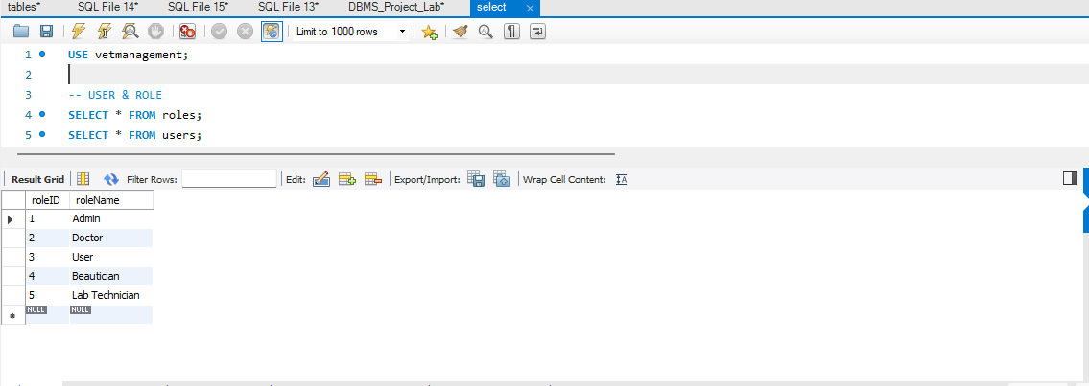
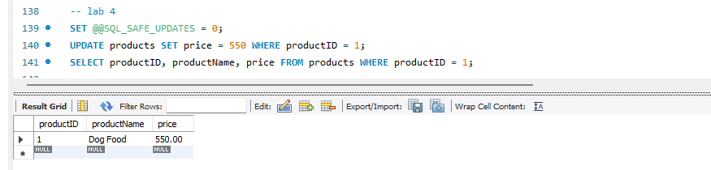
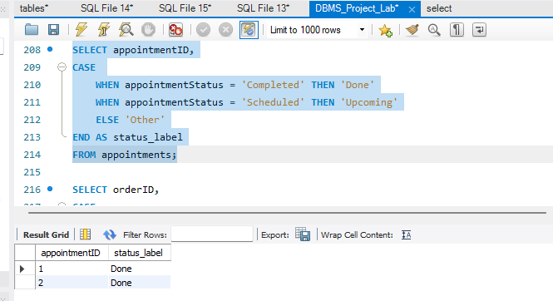

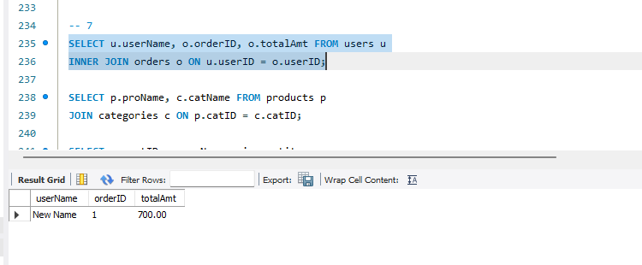
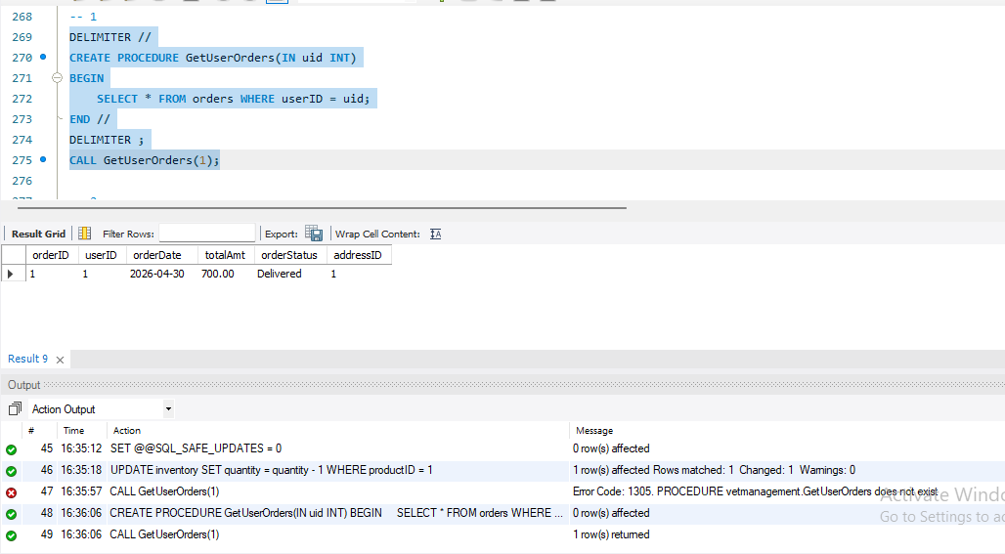
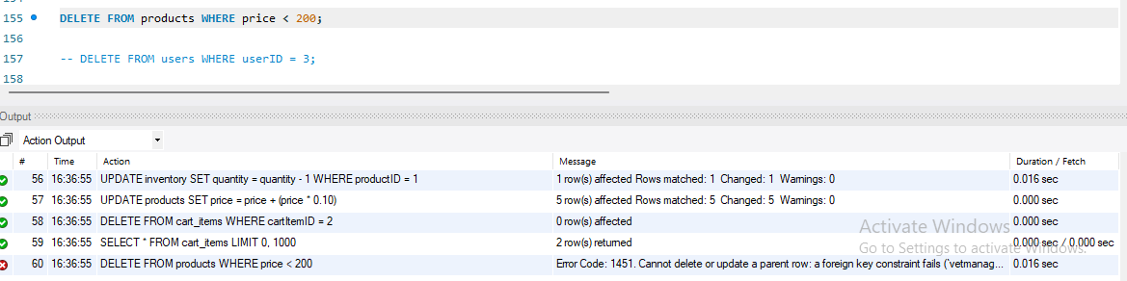
We can not delete anything from parent table if any of the columns in it re referenced by any child table column meaning the foreign key referencing a prime key. Therefore we use delete, update cascade.
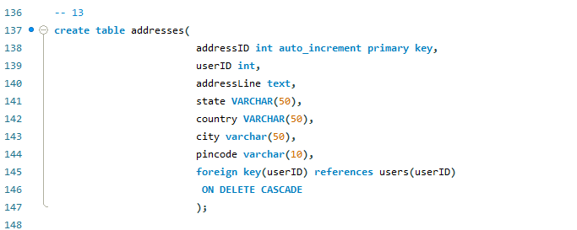

Right now quantity is 17 of a product whose productID is 2.
Now let’s assume user buys that product in 5 quantity then automatically in inventory it should be reduced and become 12(17-5) due to usage of trigger.
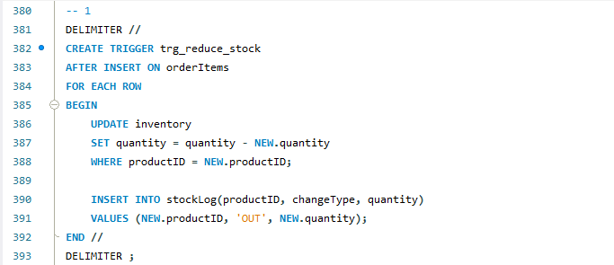
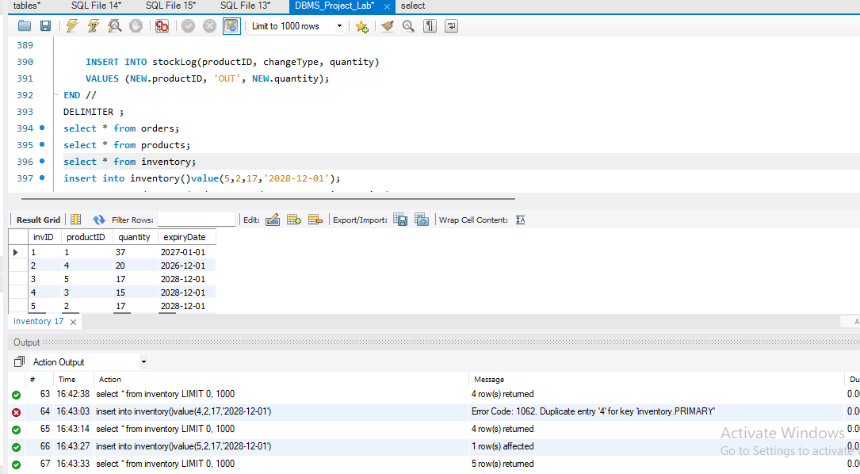
A user bought 5 quantity of a product:
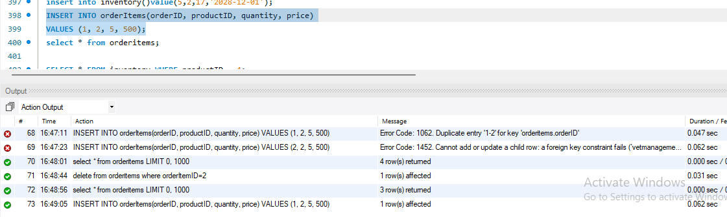
Lets check inventory
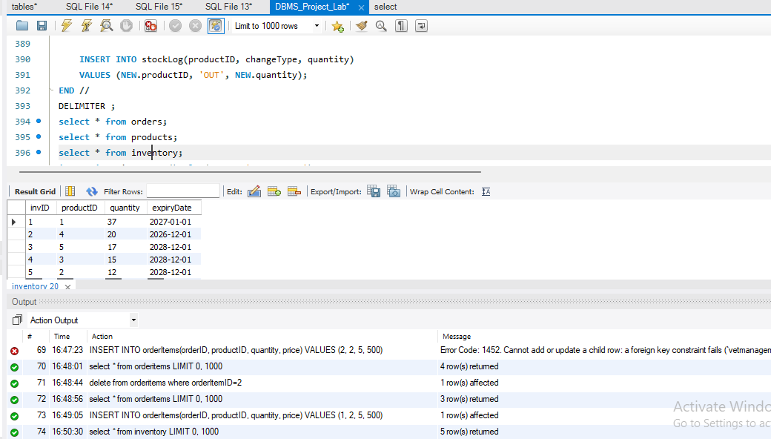
Therefore automatic update done.
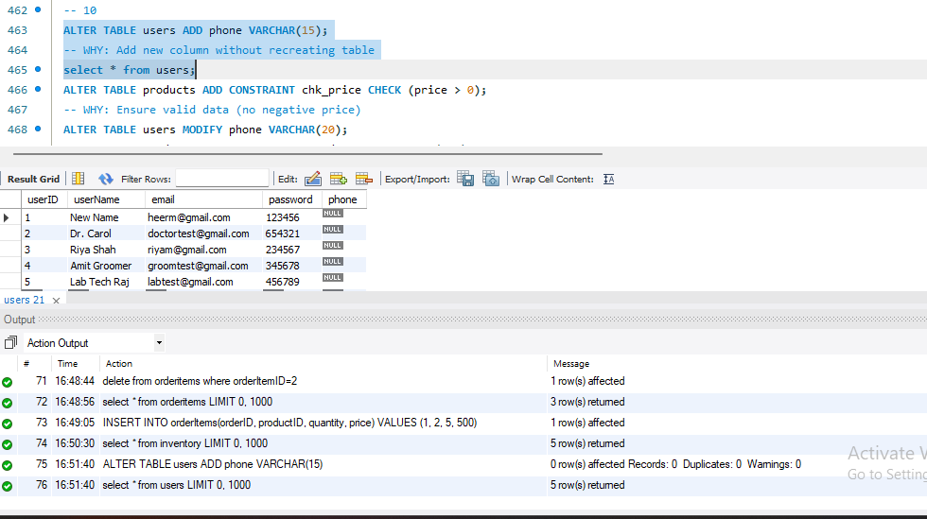
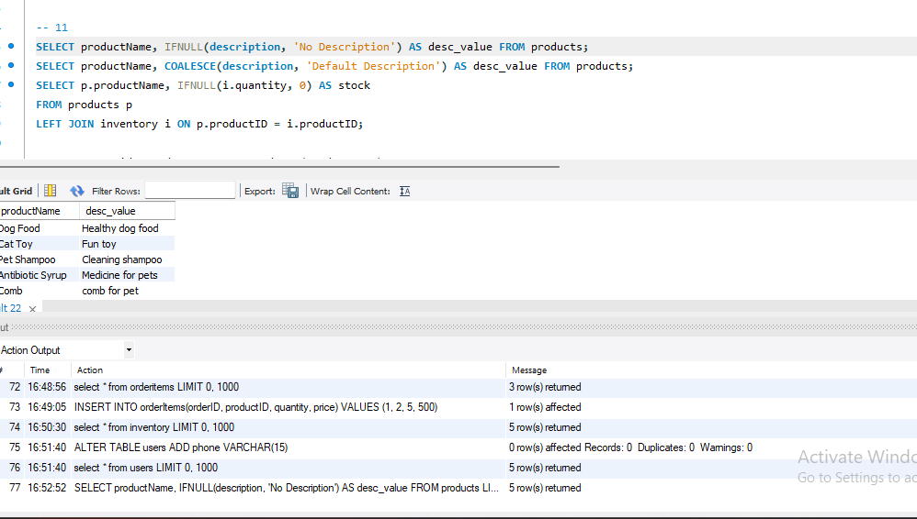
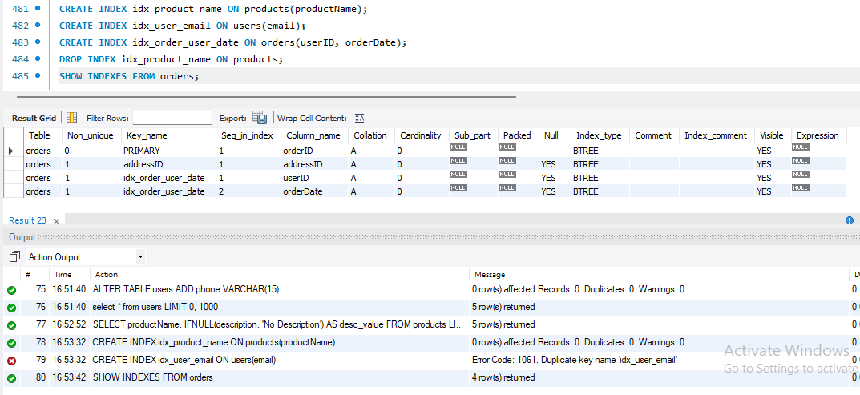
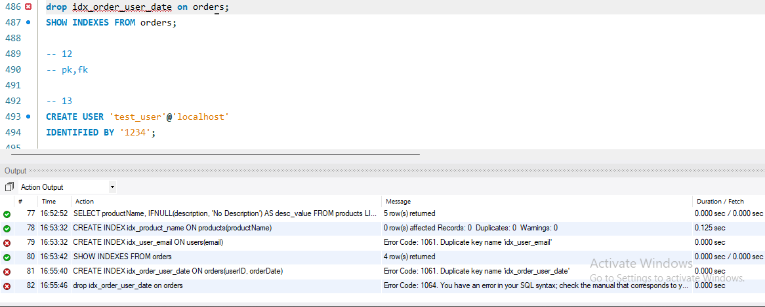
Grant given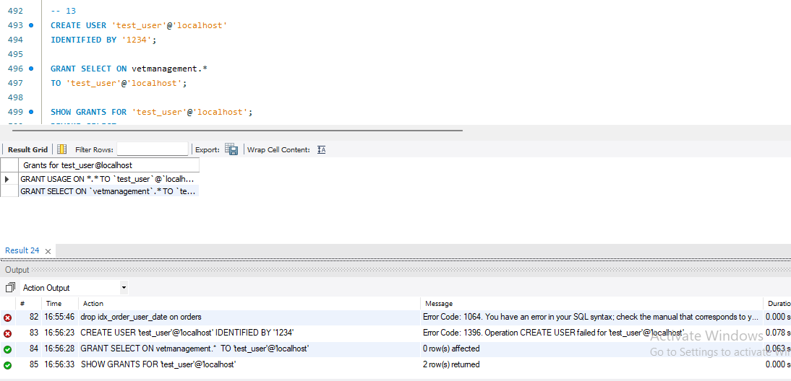
Revoked grant
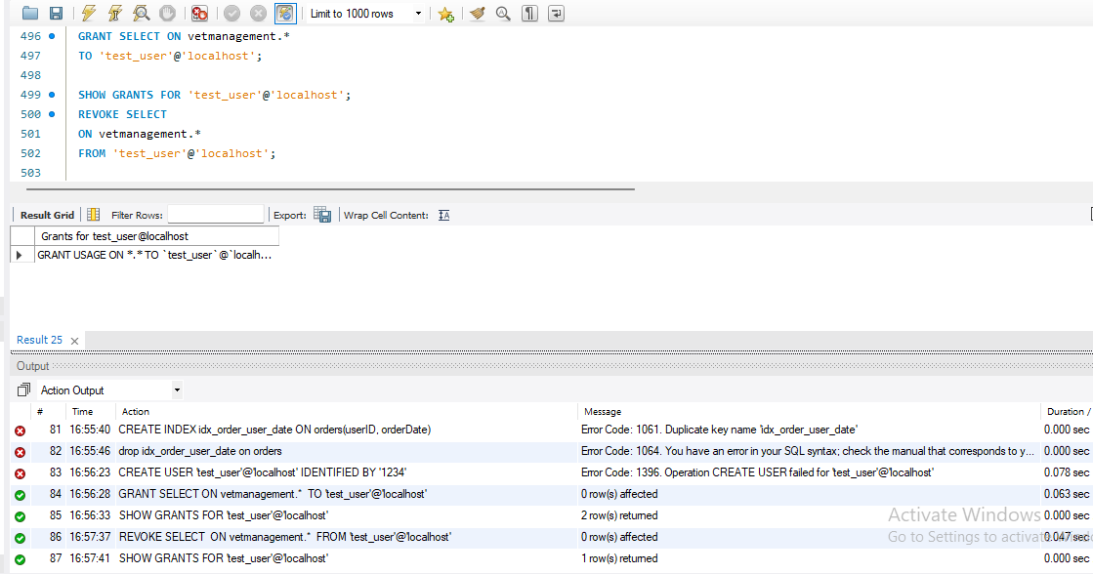
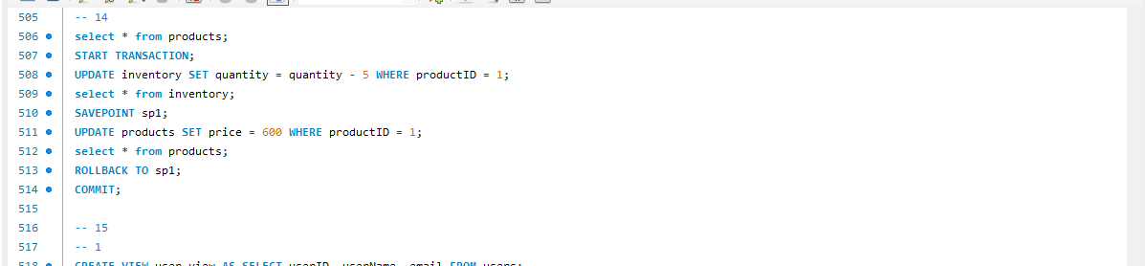
Update in view will also update the main table contents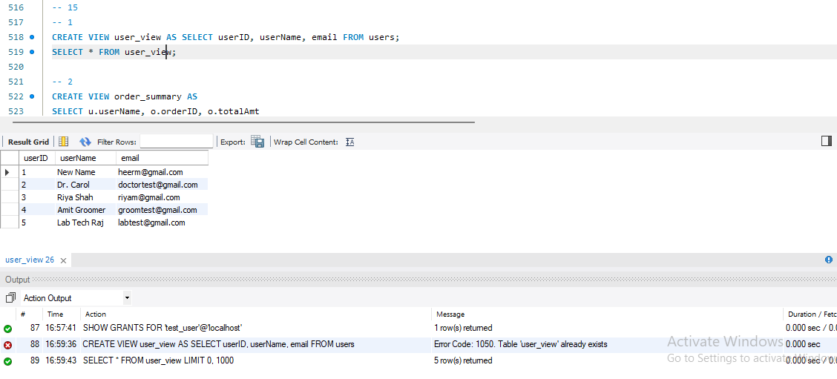

Before update main table
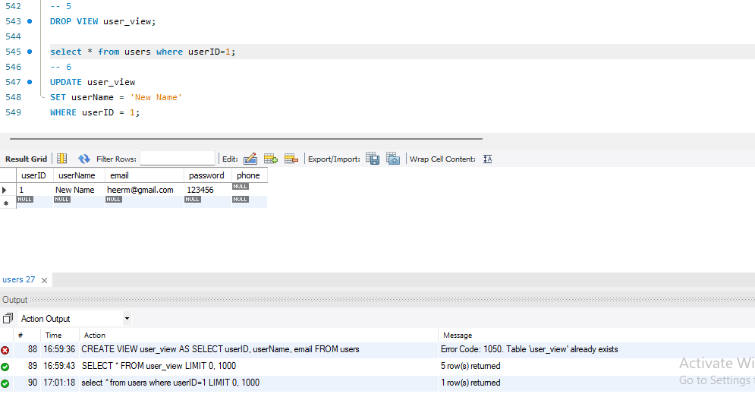
Update in view
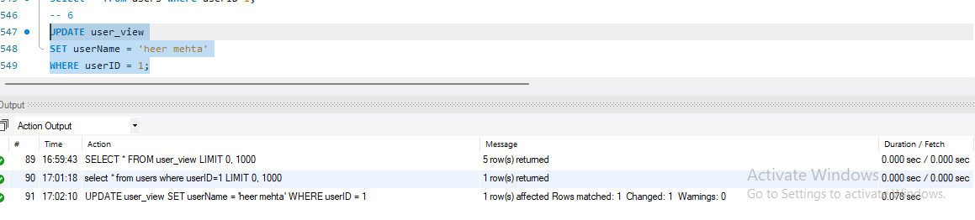
Also got updated in main table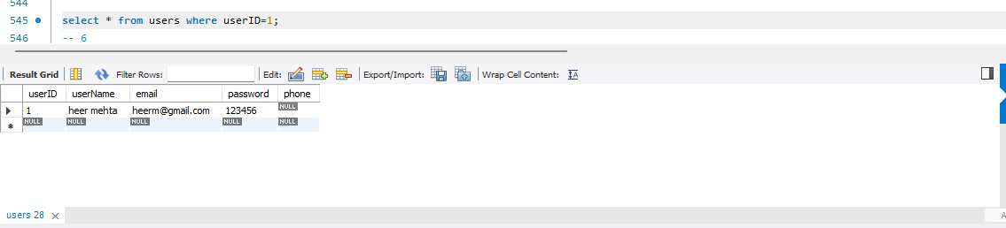

Future Scope
This project can be further enhanced to evolve into a fully functional and intelligent pet care ecosystem. One major improvement would be the integration of real-time delivery tracking, allowing users to monitor the live location and status of their orders, including medicines, pet products, and other essentials. This would significantly improve transparency and user experience.
Another valuable enhancement is the introduction of a multi-cart system, where users can maintain multiple carts simultaneously for different purposes such as medical needs, daily supplies, or grooming products, providing better organization and flexibility.
Additionally, the system can include a “Notify on Restock” feature, where users can subscribe to out-of-stock products or medicines. Whenever the item is restocked, the system will automatically send a notification to the user. This ensures that users do not miss essential products and improves customer satisfaction.
Further improvements could include integrating a secure online payment gateway, enabling subscription-based services for recurring purchases, and adding smart notifications for appointments, deliveries, and vaccinations. Advanced features like AI-based pet health recommendations and online veterinary consultations can also enhance the system’s functionality.
Adding analytics dashboards for admins and doctors would help in tracking trends, improving decision-making, and optimizing services.
Overall, these enhancements would transform the system into a scalable, user-friendly, and real-world solution that not only manages pet care services but also provides a smarter and more personalized experience for users.

Conclusion
This project represents a complete Pet Care and Veterinary Management System that brings together multiple real-world processes into one seamless workflow. It begins with users registering into the system, where they can manage their pets, book appointments with doctors, and access healthcare services. Once an appointment is scheduled, doctors can generate prescriptions, which are further broken down into individual medicines, ensuring proper tracking and flexibility.

Alongside healthcare, the system also supports an e-commerce module where users can browse products, add items to their cart, and place orders. Each order is processed through structured steps including order items, payments, and deliveries, reflecting real-world shopping experiences. Inventory is automatically managed, with stock updates and logs maintained using triggers to ensure accuracy and automation.

The system further extends into lab management, where tests and reports are generated and linked to appointments, and grooming services, where bookings and staff assignments are handled efficiently. All these modules are interconnected through a well-designed, normalized database structure that minimizes redundancy and ensures consistency.

By integrating advanced DBMS concepts like normalization, joins, triggers, stored procedures, views, indexing, and transactions, the system not only functions efficiently but also mirrors real-life workflows. Overall, this project demonstrates how a structured database can power a scalable, secure, and practical solution for managing pet care services in a unified platform.

